 A 
Industrial Oriented Mini Project Report
on

RAINFALL PREDICTION USING MACHINE LEARNING ALGORITHMS
Submitted to
Jawaharlal Nehru Technological University, Hyderabad
For the partial fulfillment of requirements for the award of the degree in
BACHELOR OF TECHNOLOGY
in

COMPUTER SCIENCE AND ENGINEERING
Submitted by
PREETHI YEDLA (21271A0529) VAISHNAVI NANDI (21271A0561)

SHRIYA MADA (21271A0555)
MD ZAYED UDDIN (22275A0505)
Under the Esteemed guidance of
Dr.R.Jegadeesan
Professor & HOD Dept of CSE

DEPARTMENT OF COMPUTER SCIENCE AND ENGINEERING
JYOTHISHMATHI INSTITUTE OF TECHNOLOGY & SCIENCE
(Autonomous, NBA (CSE, ECE, EEE) and NAAC ‘A’ Grade)
(Approved by AICTE, New Delhi, Affiliated to JNTUH, Hyderabad)
Nustulapur, Karimnagar 505481, Telangana, India 2024-2025

CERTIFICATE

This is to certify that the Mini Project Report entitled “RAINFALL PREDICTION
USING MACHINE LEARNING ALGORITHMS” is being submitted by PREETHI YEDLA
(21271A0529),VAISHNAVI NANDI (21271A0561), SHRIYA MADA (21271A0555), MOHAMMED ZAYED UDDIN (22275A0505) in partial fulfillment of the requirements for the award of the Degree of Bachelor of Technology in Computer Science and Engineering to the Jyothishmathi Institute of Technology & Science, Karimnagar, during academic year 2024 -2025, is a bonafide work carried out by them under my guidance and supervision.

The results presented in this Project Work have been verified and are found to be satisfactory. The results embodied in this Project Work have not been submitted to any other University for the award of any other degree or diploma.

Project Guide Head of the Department
Dr.R.Jegadeesan Dr.R.Jegadeesan

Professor and HOD Professor and HOD
Dept. of CSE Dept. of CSE

EXTERNAL EXAMINER

ACKNOWLEDGEMENT

We would like to express our sincere gratitude to our advisor, Dr.R.Jegadeesan, whose knowledge and guidance has motivated us to achieve goals we never thought possible.
The time we have spent working under her/his supervision has truly been a pleasure.

The experience from this kind of work is great and will be useful to us in future. We thank Dr.R.Jegadeesan, Professor & HOD CSE Dept for his effort, kind cooperation, guidance and encouraging us to do this work and also for providing the facilities to carry out this work.

It is a great pleasure to convey our thanks to Dr.T.Anil Kumar, Principal, Jyothishmathi Institute of Technology & Science and the College Management for permitting us to undertake this project and providing excellent facilities to carry out our project work.

We thank all the Faculty members of the Department of Computer Science & Engineering for sharing their valuable knowledge with us We extend our thanks to the Technical Staff of the department for their valuable suggestions to technical problems. Finally Special thanks to our parents for their support and encouragement throughout our life and this course Thanks to all our friends and well-wishers for their constant support.

DECLARATION

We hereby declare that the work which is being presented in this dissertation entitled, “RAINFALL
PREDICTION USING MACHINE LEARNING ALGORITHMS”, submitted towards the partial fulfillment of the requirements for the award of the degree of Bachelor of Technology in Computer Science & Engineering, Jyothishmathi Institute of Technology & Science,
Karimnagar is an authentic record of our own work carried out under the supervision of
Dr.R.Jegadeesan, Department of CSE, Jyothishmathi Institute of Technology and Science,
Karimnagar

To the best of our knowledge and belief, this project bears no resemblance with any report submitted to JNTUH or any other University for the award of any degree or diploma.

PREETHI YEDLA (21271A0529)
VAISHNAVI NANDI (21271A0561)
SHRIYA MADA (21271A0555)
MOHAMMED ZAYED UDDIN (22275A0505)

Date:
Place: Karimnagar

ABSTRACT
Rainfall prediction has been a challenging task for meteorological departments for years due to the drastically unpredictable behavior of the climate. Global warming is significantly affecting the world, creating major impacts on humankind and accelerating climate change. One of the most notable consequences of this phenomenon is uneven rainfall. Precipitation, as a critical climatic factor, influences various human activities, including agricultural production, construction, energy generation, and tourism. These dependencies highlight the necessity of accurate and reliable rainfall forecasting systems to mitigate risks and support planning in these sectors. The project, titled “Rainfall Prediction Using Machine Learning Algorithms,” aims to address this issue by predicting rainfall occurrences based on historical rainfall data from various Indian states. By leveraging machine learning techniques, the project employs several supervised algorithms, such as Random Forest, Gradient Boost, Logistic Regression, and Support Vector Machines, to analyze complex patterns and forecast rainfall effectively. Furthermore, the project emphasizes optimizing predictive accuracy by comparing the performance of the chosen machine learning models. Through this comparative analysis, it identifies the most suitable algorithm for rainfall prediction, ensuring robust and precise results. The outcomes of this project contribute to the development of innovative data-driven solutions in meteorology and enhance decision-making processes in sectors dependent on weather forecasts.

ⅰ

TABLE OF CONTENTS

CHAPTER NO TITLE PAGE NO

ABSTRACT i
LIST OF FIGURES v
LIST OF ABBREVIATIONS vi

1 INTRODUCTION 1
1.1 Project Overview 1
1.2 Project Purpose 2
1.3 Project Scope 4
1.4 Project Features 5
2 LITERATURE REVIEW 6

3 EXISTING & PROPOSED SYSTEM 11
3.1 Existing System 11
3.2 Existing System Disadvantages 12
3.3 Problem Statement 13
3.4 Proposed System 14
3.5 Proposed System Advantages 14

4 SYSTEM REQUIREMENTS 14
4.1 Software Requirements 14
4.2 Hardware Requirements 14

5 PROJECT DESCRIPTION 15
5.1 Modules 15
5.1.1 Data pre-processing 15
5.1.2 Random Forest 16
5.1.3 SVM 17
5.1.4 KNN 17

6 SYSTEM DESIGN 18
6.1 System Architecture 18
6.2 Data Flow Design 20
6.3 UML Design 21
6.3.1 Use Case Diagram 22
6.3.2 Class Diagram 23
6.3.3 Activity Diagram 25
6.3.4 Sequence Diagram 26
- SOFTWARE SPECIFICATIONS 27
7.1 Python 27

8 IMPLEMENTATION 28
8.1 Installations 29 8.2 Code 29

9 SOFTWARE TESTING 35
9.1 Unit Testing 35
9.2 Integration Testing 35
9.3 System Testing 35
9.4 Acceptance Testing 36
31
9.5 Performance Testing 36
9.6 Security Testing 36
9.7 Compatibility Testing 36
10 RESULTS 37

11 CONCLUSION 43
- FUTURE SCOPE 44
- REFERENCES 45

LIST OF FIGURES

FIGURE NO NAME OF THE FIGURE PAGE NO
6.1 System Architecture 20
6.2 Data Flow Diagram 21
6.3.1 Use Case Diagram 23
6.3.2 Class Diagram 24
6.3.3 Activity Diagram 25
6.3.4 Sequence Diagram 26
10.1 Info 37
10.2 Rainfall in months w.r.to year 38
10.3 Sub-division v/s Rainfall in each month 38
10.4 Sub-division into each state 39
10.5 Telangana Rainfall v/s months 39
10.6 Telangana Rainfall v/s months 40
10.7 Models & their Representative Models 40
10.8 Models & their Representative Models 41
10.9 Models & their Representative Models 41
10.10 Summary of results 42

LIST OF ABBREVIATIONS
KNN | - | K-Nearest Neighbor
SVM | - | Support Vector Machines
RF | - | Random Forest
CPU | - | Central Processing Unit
HDD | - | Hard Disk Drive
RAM | - | Random Access Memory
GB | - | Giga Bytes
DFD | - | Data Flow Diagram
UML | - | Unified Modeling Language

CHAPTER 1

INTRODUCTION

1.1 PROJECT OVERVIEW

The project “Rainfall Prediction Using Machine Learning Algorithms” is designed to tackle the complex and ongoing challenge of accurately predicting rainfall. This project recognizes the critical importance of reliable weather forecasting, particularly in regions where rainfall directly impacts various industries such as agriculture, water resources, energy, and construction. Traditional methods of rainfall prediction, such as statistical models or rule-based systems, have been in use for many years. However, these methods often fail to capture the non-linear relationships between multiple climatic variables, or they rely on a limited dataset. This is where machine learning comes in, offering the ability to process large volumes of data, identify hidden patterns, and make predictions with a higher level of accuracy.

Machine learning, particularly supervised learning algorithms, has emerged as a gamechanger in predictive modelling. In this project, we employ four prominent machine learning algorithms—Random Forest, k nearest neighbor (KNN), Logistic Regression, and Support Vector Machines (SVM)—to predict rainfall based on historical data from various states of India. These algorithms are known for their robustness and ability to handle complex datasets with many variables, such as temperature, humidity, wind speed, and atmospheric pressure. These algorithms learn from the data and make predictions based on recognized patterns and correlations that human experts might overlook. By comparing the results of each algorithm, the project aims to determine which provides the most accurate rainfall predictions for each region and season.

This project aims to address the growing demand for accurate and timely weather predictions to support key sectors. The overarching goal is to improve agricultural practices by predicting rainfall events with greater reliability, allowing farmers to adjust their irrigation schedules and crop planning accordingly. Additionally, by improving rainfall forecasts, we can assist in better management of water resources, helping to avoid shortages or overflows. The energy sector, particularly hydropower, can also benefit from more accurate rainfall data, helping optimize power generation. Furthermore, better predictions could significantly improve disaster preparedness, especially for floods or droughts, providing early warnings to mitigate damage.
The significance of this project is magnified in light of the ongoing challenges posed by climate change. With the rise in global temperatures, rainfall patterns have become more erratic and unpredictable. This has placed immense pressure on various sectors that rely heavily on consistent weather patterns, such as agriculture, energy production, and water resource management. Machine learning provides an opportunity to enhance the predictability of these systems, helping mitigate the risks posed by the increasing volatility in weather patterns.

1.2 PROJECT PURPOSE

The primary purpose of this project is to provide more accurate rainfall forecasts through the use of machine learning techniques. By employing data-driven approaches, the project aims to surpass the limitations of traditional forecasting models, which often fail to capture complex relationships in large, multifactorial data sets. Machine learning models can work with diverse data sources and non-linear relationships, providing improved insights into the underlying factors that influence rainfall events. The goal is not just to predict rainfall, but to provide actionable insights that can be used to optimize decision-making in areas such as agriculture, water management, and disaster mitigation.

Agriculture is one of the sectors that would benefit significantly from this project. Reliable rainfall forecasts allow farmers to plan better, ensuring that irrigation schedules are optimized and that crops are planted at the most appropriate times. In regions where irrigation is a necessity, this project can help conserve water resources and improve crop yield by predicting rainfall events ahead of time. The project aims to equip farmers with the tools they need to mitigate the effects of water scarcity and unpredictable weather events, increasing both food security and sustainability.

Another key purpose of the project is to improve water resource management. Accurate predictions of rainfall can assist in managing the storage and distribution of water in reservoirs and dams, optimizing water use and preventing both shortages and flooding. Water managers can make more informed decisions about when and where to release water, particularly in regions that experience seasonal rainfall or fluctuating rainfall patterns. Furthermore, the project can support the energy sector by improving the forecasting of water levels in hydropower plants, ensuring that these plants can operate efficiently and provide power during peak demand times.
Disaster management is another area where the project’s impact could be substantial. Floods, droughts, and other extreme weather events often result in significant human and financial loss. By providing earlier warnings, better rainfall predictions could allow governments and organizations to prepare for these events, deploy emergency resources, and minimize the adverse effects. Improved forecasting can also lead to better infrastructure planning, ensuring that cities and towns are built to withstand the impacts of extreme weather, whether in terms of drainage systems, water storage, or flood defenses.

The project is also intended to contribute to the broader field of climate science by demonstrating how machine learning can be applied to meteorology. With the increasing availability of climate data, the potential for machine learning to analyse this data and provide meaningful predictions is immense. This project serves as a proof of concept for how these technologies can be used to enhance weather forecasting and offer real-world solutions to contemporary environmental challenges.

1.3 PROJECT SCOPE

The scope of this project encompasses a broad range of applications, making it highly relevant to multiple sectors that depend on accurate weather forecasting. The primary focus is on enhancing rainfall prediction by applying machine learning algorithms to historical weather data. The project aims to evaluate and compare various machine learning models, including Random Forest, Gradient Boost, Logistic Regression, and Support Vector Machines, to identify the most accurate models for predicting rainfall in different regions of India. These regions, with their varying climates and geographic conditions, provide an excellent testbed for assessing the robustness and adaptability of these models.

In addition to improving prediction accuracy, the project also aims to refine data preprocessing techniques. Raw weather data is often inconsistent and incomplete, which can undermine the effectiveness of predictive models. By incorporating data-cleaning strategies like handling missing values and correcting erroneous data, the project ensures that the machine learning models receive high-quality input for training. Furthermore, feature extraction and selection techniques will be applied to identify the most relevant climatic factors influencing rainfall, thereby improving the predictive accuracy and efficiency of the models.

The project’s scope also allows for potential future advancements. As machine learning methodologies continue to evolve, the system can be expanded to include more advanced techniques, such as deep learning networks, to further boost prediction accuracy. Additionally, real-time data collection methods, such as satellite imagery and sensor networks, can be integrated into the system to continuously update forecasts and improve the overall reliability of the predictions. This will make the system more dynamic, capable of providing up-to-date and precise rainfall forecasts.

Lastly, the project has significant potential for expansion beyond India. Given the global impacts of climate change, the need for accurate rainfall predictions is not confined to one region. By modifying the dataset and adjusting model parameters, the system can be adapted for use in different parts of the world, offering a scalable solution for improving rainfall prediction globally. This global applicability ensures the project can contribute to better decision-making and resource management across the world.

1.4 PROJECT FEATURES

Machine Learning Algorithms: Utilizes supervised machine learning algorithms such as
Random Forest, Gradient Boost, Logistic Regression, and Support Vector Machines (SVM). Comparative analysis of algorithms to determine the most accurate and effective model for rainfall prediction.

Data Preprocessing: Raw data is cleaned and pre-processed to handle inconsistencies such as missing values and errors. Feature extraction and selection are performed to identify the most relevant factors influencing rainfall, improving model accuracy and reducing complexity.

Model Evaluation: Models are trained using historical rainfall data and evaluated using performance metrics like Mean Absolute Error (MAE), Mean Squared Error (MSE), and Root Mean Squared Error (RMSE). The best performing model is selected based on its predictive accuracy

Data Visualization: Visual representation of trends, predictions, and correlations through graphs and charts. Visual tools help users easily interpret forecast results and make informed decisions based on the predictions.

Scalability: The system can be adapted to different geographical locations, climatic conditions, and timeframes. Can be extended for global applications by modifying datasets and adjusting model parameters.

User-Friendly Interface: The project includes an easy-to-use interface to display prediction results and analysis. Results are presented in a format that is accessible to non-technical users, including stakeholders in agriculture, water management, and disaster management.

Real-Time Data Integration: Future enhancements will integrate real-time data from weather stations, satellite imagery, or IoT devices. Provides up-to-date predictions and improves forecasting accuracy over time.

Adaptability: The model can continuously adapt and improve as more data becomes available or weather patterns change. Capable of retraining the machine learning models to maintain high prediction accuracy as new trends and patterns emerge.

Improved Decision-Making: Facilitates better decision-making for stakeholders, such as farmers, disaster management authorities, and water resource managers. Enables optimized planning in sectors dependent on accurate rainfall predictions.

CHAPTER 2 LITERATURE REVIEW

Title: Rainfall Prediction Using Machine Learning Algorithms ● Author(s): Pritpal Singh, Sam Carmer, et al.
- Published Date: 2020 Details:
This paper explores the use of machine learning algorithms for enhancing rainfall prediction accuracy, with specific focus on supervised learning models such as Random Forest, Support Vector Machines. The authors evaluate the performance of these algorithms on historical weather data from India, comparing their effectiveness in terms of predictive accuracy and computational efficiency. The study concludes that Random Forest is the most accurate model for this application due to its robustness and ability to handle large datasets with missing values. This paper highlights the potential of machine learning in addressing the limitations of traditional weather forecasting methods, particularly in developing countries with limited meteorological infrastructure.

Title: A Survey on Machine Learning Models for Weather Prediction
- Author(s): Amandeep Kaur, Arvind Kumar

● Published Date: 2019
Details:
This review paper surveys various machine learning techniques used in weather prediction, with a primary focus on rainfall forecasting. The authors examine neural networks, decision trees, and support vector machines for their ability to handle weather-related datasets. They discuss the advantages and limitations of each technique, highlighting how recurrent neural networks (RNNs) and long short-term memory (LSTM) models can capture sequential relationships in time-series data like rainfall patterns. The paper suggests that deep learning models, especially those built on LSTMs, offer superior performance for time-series forecasting compared to traditional models. The authors emphasize that data quality, model training on large datasets, and computational efficiency are significant challenges for these machine learning-based approaches.

Title: Challenges in Rainfall Prediction and the Role of Big Data
- Author(s): Rajesh Kumar, Devika Pandey
- Published Date: 2021 Details:
This paper addresses the challenges in rainfall prediction, particularly the need for Big Data analytics to improve accuracy. The authors explore how vast datasets from satellite imagery, weather stations, and Internet of Things (IoT) sensors can be integrated into machine learning models. They discuss the role of Big Data platforms like Hadoop and Apache Spark for data processing and feature extraction. The paper suggests that the combination of machine learning algorithms with Big Data technologies can provide more accurate and timely rainfall predictions, especially in regions with scarce or incomplete data. The authors also argue that cloud computing plays a crucial role in making such predictive models scalable and accessible, ensuring that even developing regions can adopt these technologies for enhanced meteorological forecasting.

Title: Application of Random Forest and SVM in Climate Prediction
- Author(s): Emily Thompson, John K. Smith
- Published Date: 2018 Details:
This study compares Random Forest and Support Vector Machines (SVM) for climate and rainfall prediction. The authors demonstrate that Random Forest is highly effective for handling large, complex datasets due to its ensemble learning approach, which reduces overfitting and improves predictive accuracy. They also highlight the advantages of SVM in classifying rainfall patterns but note that SVM requires careful tuning of hyperparameters, particularly the kernel function, to perform well on climate datasets. The paper suggests combining these two models into an ensemble model to capitalize on the strengths of both techniques and provide more accurate predictions for rainfall and other climate variables.

Title: Climate Change and Its Impact on Rainfall Patterns in India
- Author(s): Rajendra K. Singh, Kumar Jha
- Published Date: 2022 Details:
This paper examines how climate change has altered rainfall patterns in India, making it more unpredictable and leading to increased variability. The study uses historical data to analyze long-term trends and assesses how changes in temperature and humidity affect the seasonal distribution of rainfall. The authors also explore how machine learning can be used to model and predict these new rainfall patterns, emphasizing the need for more region-specific forecasting. The paper highlights that machine learning models, when properly trained, can help mitigate the adverse effects of climate change on agriculture and water resources by providing more accurate and timely predictions.

Title: Machine Learning in Meteorology: A Review of Recent Advances
- Author(s): Maria Carter, John T. Lee
- Published Date: 2021 Details:
This review paper focuses on recent advancements in machine learning applied to meteorology, especially for weather prediction tasks like rainfall forecasting. The authors highlight the increasing use of artificial neural networks (ANNs), deep learning models, and ensemble methods in improving the accuracy and efficiency of rainfall predictions. They discuss the advantages of combining statistical models with machine learning to improve robustness and handle non-linearities in weather data. The paper also addresses challenges such as data scarcity, model interpretability, and the need for real-time processing in meteorological applications.

Title: Big Data Analytics in Weather Forecasting: Challenges and Opportunities
- Author(s): Neelam Sharma, Vikram Singh

• Published Date: 2020
Details:
This paper explores the integration of Big Data with weather forecasting techniques, particularly for rainfall prediction. The authors discuss how Big Data analytics tools such as Hadoop, MapReduce, and Spark can handle massive amounts of data from satellite observations, weather stations, and sensors. The paper outlines the potential benefits of combining Big Data with machine learning models, such as more accurate and timely rainfall predictions. It also covers challenges such as data preprocessing, sensor calibration, and ensuring that data from multiple sources is harmonized and ready for use in predictive models.

Title: Predicting Rainfall with Random Forest and Gradient Boosting Models: A Comparative Study
- Author(s): Anjali Gupta, Rohan Verma
- Published Date: 2023 Details:
This paper presents a comparative study of Random Forest and Gradient Boosting for rainfall prediction. The authors focus on evaluating both algorithms' performance using various weather parameters such as temperature, humidity, and wind speed. They find that while Random Forest excels in handling noisy data and missing values, Gradient Boosting provides higher predictive accuracy, particularly when tuned with learning rates and depth parameters. The paper suggests that a hybrid model, combining both approaches, can provide the best of both worlds for rainfall forecasting.

Title: A Review on Hybrid Models for Rainfall Prediction
- Author(s): Pradeep Kumar, Neha Patel
- Published Date: 2020 Details:
This paper reviews the use of hybrid models that combine machine learning and traditional statistical techniques for rainfall prediction. The authors explore how combining models like Random Forest with Time Series Analysis or Neural Networks with regression techniques can improve prediction accuracy. The paper concludes that hybrid models are more efficient in handling both linear and non-linear relationships within weather data, and they offer enhanced generalization compared to individual models.
CHAPTER 3

EXISTING & PROPOSED SYSTEM

3.1 EXISTING SYSTEM

The existing systems for rainfall prediction primarily rely on traditional meteorological models, which include statistical methods, physical and numerical weather prediction models, and empirical approaches. Statistical models use historical weather data to predict rainfall based on identified correlations, but they struggle with non-linear relationships and complex patterns. Numerical Weather Prediction (NWP) models simulate atmospheric processes using physical laws, providing large-scale forecasts, but they require significant computational power and may not be effective for localized predictions. Empirical methods, often based on observed trends, are less accurate and often fail to predict extreme weather events.

Despite their widespread use, these existing systems have notable limitations. They often rely on sparse or incomplete data, which affects their accuracy. Additionally, traditional models cannot account for the dynamic, non-linear interactions between various climatic factors, leading to less reliable forecasts, especially in regions with complex weather patterns. Moreover, these systems may not be well-suited for localized rainfall predictions, which are crucial for sectors like agriculture and disaster management. As a result, there is a growing need for more advanced systems that can better handle complex data and improve forecasting accuracy.

3.2 EXISTING SYSTEM DISADVANTAGES

Limited Accuracy: Traditional rainfall prediction systems, especially statistical and empirical models, often provide inaccurate forecasts due to their inability to handle complex, non-linear relationships between climatic variables. These models struggle to adapt to changing weather patterns, which results in lower prediction accuracy, particularly for localized rainfall events.

Data Dependency and Gaps: Many existing systems rely on historical weather data that may be incomplete, inconsistent, or sparse. Missing data or irregularities in recorded measurements can significantly affect the reliability of forecasts, reducing the effectiveness of predictions, especially in regions with limited data availability.
Inability to Handle Complex Interactions: Existing models generally assume linear relationships between weather variables, which oversimplifies the complexity of atmospheric systems. Rainfall patterns are influenced by numerous interconnected factors, and traditional systems often fail to capture these non-linear interactions, leading to less accurate forecasts.

High Computational Requirements: Numerical Weather Prediction (NWP) models, which use physical laws to simulate weather patterns, require significant computational resources and are often limited to well-funded meteorological institutions. These systems may not be feasible for smaller organizations or regions with limited infrastructure, making them inaccessible for many.

Limited Spatial and Temporal Resolution: Traditional systems may not perform well in predicting localized rainfall patterns due to their reliance on large-scale weather models. They often lack the resolution needed to make accurate predictions for specific areas, which is critical for sectors like agriculture, water resource management, and disaster preparedness.

Slow Adaptability to Climate Change: Traditional rainfall prediction systems can be slow to adapt to the impacts of climate change, as they typically rely on historical data that may not fully account for new or shifting climate patterns. As a result, they may fail to predict extreme weather events or changing seasonal trends effectively.

3.3 PROBLEM STATEMENT

Rainfall prediction remains a critical challenge for meteorological departments due to the highly unpredictable nature of climate and the limitations of traditional forecasting models. Existing systems, including statistical models and numerical weather prediction, often struggle to accurately predict rainfall, especially under changing climatic conditions. These models fail to account for complex, non-linear relationships between climatic variables, leading to inaccurate forecasts. Additionally, traditional methods rely heavily on incomplete or sparse historical data, which further diminishes their accuracy and reliability.

The inability to provide precise, localized rainfall predictions affects sectors like agriculture, water resource management, and disaster preparedness. Farmers struggle with irrigation and crop planning due to inconsistent forecasts, while water management systems often face difficulties in optimizing water storage and distribution. Furthermore, inadequate rainfall predictions leave communities vulnerable to the impacts of floods and droughts, complicating disaster response efforts. There is a pressing need for more accurate, data-driven forecasting systems that can handle large, dynamic datasets and provide localized, real-time rainfall predictions to support better decision-making in these vital sectors.

3.4 PROPOSED SYSTEM

The proposed system leverages machine learning algorithms to enhance the accuracy of rainfall prediction. By using supervised learning techniques like Random Forest, Gradient Boost, Logistic Regression, and Support Vector Machines, the system can analyze historical weather data and identify complex patterns that traditional models miss. The system employs data preprocessing to clean and handle incomplete or missing data, ensuring high-quality inputs for the machine learning models. A comparative analysis of these algorithms will identify the most accurate model for predicting rainfall in different regions.

This system offers more localized and precise rainfall forecasts, which can be adapted to different geographical regions. The use of real-time data integration, such as satellite imagery and sensor networks, will further improve prediction accuracy. It will also be scalable, enabling global application. Ultimately, the proposed system will provide better support for sectors like agriculture, water management, and disaster response by enabling more reliable decision-making based on accurate rainfall predictions.

3.5 PROPOSED SYSTEM ADVANTAGES

Improved Accuracy: By using advanced machine learning algorithms, the proposed system can capture complex, non-linear relationships between climatic variables, leading to more accurate rainfall predictions compared to traditional models.

Data-Driven Insights: The system leverages vast historical weather data to identify patterns and trends, allowing it to make predictions based on real-time, dynamic data, ensuring better adaptability to changing climate conditions.
Localized Predictions: Unlike traditional models that often lack spatial resolution, the proposed system can provide more localized rainfall forecasts, which is crucial for sectors like agriculture, water management, and disaster preparedness.

Real-Time Data Integration: The ability to integrate real-time data from sources such as weather stations, satellite imagery, and IoT sensors ensures up-to-date predictions, enhancing the system's responsiveness to current weather conditions.

Scalability: The system is adaptable to various regions and climatic conditions, making it globally applicable. It can be customized to fit local weather patterns and data, providing accurate predictions across different geographical areas.

Efficient Resource Management: More accurate rainfall forecasts help sectors like agriculture and water management plan better, optimize water resources, and reduce waste, improving overall efficiency.

Disaster Mitigation: Timely and accurate rainfall predictions aid in flood and drought forecasting, allowing authorities to take preventive measures and allocate resources effectively, reducing the risk of natural disasters.

Cost-Effective: The system can reduce the reliance on costly and resource-intensive traditional weather prediction models by automating the prediction process with machine learning, making it a more cost-effective solution.

Continuous Improvement: As more data is collected and processed, the system can continuously improve its predictive accuracy through retraining, ensuring that it adapts to new weather patterns and climate trends over time.

CHAPTER 4

SYSTEM REQUIREMENTS

4.1 SOFTWARE REQUIREMENTS

Software Requirements specifies the logical characteristics of each interface and software components of the system. The following are the software requirements
- Operating System : Windows 7 or above / macOS
- Programming Language : Python

4.2 HARDWARE REQUIREMENTS

Hardware interfaces specify the logical characteristics of each interface between the software product and the hardware components of the system. The following are some hardware requirements.
- Minimum 2GB RAM or more
- CPU (intel i3 or more)
- Minimum 80 GB HDD or more

CHAPTER 5

PROJECT DESCRIPTION

The Rainfall Prediction Using Machine Learning Algorithms project aims to provide accurate rainfall forecasts by utilizing advanced machine learning techniques. The system employs supervised learning models such as Random Forest, K nearest neighbor (KNN), Logistic Regression, and Support Vector Machines (SVM) to analyze historical weather data from various regions. By processing large datasets, the system identifies hidden patterns and trends that traditional models often miss.

Data preprocessing techniques are used to clean and handle missing or inconsistent data, ensuring the reliability of input. The project compares multiple machine learning algorithms to determine the most effective one for predicting rainfall in specific areas. Realtime data integration, including satellite images and sensor data, further enhances prediction accuracy.

The system’s scalability allows it to be applied in different geographic regions, making it adaptable to varying climate conditions. The ultimate goal is to support critical sectors such as agriculture, water management, and disaster mitigation by providing more accurate and timely rainfall predictions, thus enabling better decision-making.

5.1 MODULES
5.1.1 DATA PRE-PROCESSING

Data pre-processing is an essential step in machine learning and data mining that involves transforming raw, inconsistent, and incomplete data into a clean and structured format suitable for modelling. Raw data often contains missing values, errors, and irrelevant features, making it unreliable for accurate predictions. The goal of data pre-processing is to enhance the quality of the data and ensure that the models can learn effectively. In this project, one common technique for handling missing data is by replacing null values with their mean or median, depending on the nature of the data, to maintain the overall dataset's integrity.

Another approach is to remove entire rows or columns that contain too many missing or irrelevant values, especially when they do not contribute meaningfully to the analysis. Data exploration helps identify columns that may be redundant or non-contributory to the model, allowing for better feature selection. Additionally, data normalization or standardization techniques are applied to ensure that numerical features are on the same scale, preventing certain features from disproportionately influencing the model.

Outliers and errors are also detected and corrected during this phase, which ensures that the model is not misled by extreme values. By cleaning and transforming the data in these ways, we make sure that the machine learning model receives a consistent and accurate dataset, ultimately improving the performance and reliability of rainfall predictions.

5.1.2 RANDOM FOREST

Random Forest is a powerful and widely used machine learning algorithm that falls under the category of supervised learning. It can be applied to both classification and regression tasks, making it versatile for a variety of predictive modelling problems. The algorithm is based on the concept of ensemble learning, which involves combining multiple models to improve the performance and robustness of the overall prediction. Instead of relying on a single model, Random Forest creates an ensemble of decision trees, each built using a random subset of the data and features.

Each decision tree in the Random Forest is trained on a different sample of the dataset, and the final prediction is made by aggregating the predictions from all the trees. For classification tasks, the model uses the majority voting mechanism, where the class predicted by the majority of trees becomes the final prediction. In regression problems, the final output is determined by averaging the predictions from all the individual trees.

One of the key advantages of Random Forest is its ability to reduce the problem of overfitting—a common issue in decision trees—by introducing randomness and averaging the results. The more trees in the forest, the higher the model’s accuracy, as the randomness ensures that the algorithm generalizes better rather than memorizing specific patterns. Random Forest also handles large datasets efficiently, can deal with missing values, and provides an insight into feature importance, which helps in identifying the most relevant features for prediction.

5.1.3 SUPPORT VECTOR MACHINE

Support Vector Machine (SVM) is a highly effective supervised learning algorithm primarily used for classification tasks, although it can also be applied to regression problems. The primary goal of SVM is to find the best decision boundary, known as a hyper-plane, that separates different classes in the dataset. This hyper-plane divides the data into distinct categories in such a way that it maximizes the margin between the classes. In simple terms, SVM aims to create the widest possible gap between the two classes while ensuring that the data points are correctly classified.

The SVM algorithm works by identifying support vectors, which are the data points closest to the decision boundary. These support vectors are critical because they define the position and orientation of the hyper-plane. The hyper-plane is determined by these extreme points, and the algorithm uses them to achieve the best classification performance.

SVM is known for its effectiveness in high-dimensional spaces and its ability to handle both linearly separable and non-linearly separable data. It also performs well with smaller datasets and is robust against overfitting, especially in high-dimensional spaces. Despite this, SVM is a powerful tool for classification problems in machine learning.

5.1.4 KNN

K-Nearest Neighbors (KNN) is a straightforward, non-parametric supervised learning algorithm used for classification and regression tasks. It classifies a data point based on the majority class of its K nearest neighbors in the feature space. For classification, the data point is assigned to the class that appears most frequently among its K nearest neighbors, while in regression, the output is the average of the neighbors values. The algorithm relies on distance metrics like Euclidean or Manhattan distance to calculate the closeness between data points.

One of KNN's main advantages is its simplicity and ease of implementation. However, it can be computationally expensive, especially for large datasets, as it requires calculating the distance to every point in the training set for each query. The performance of KNN is highly dependent on the choice of K and the distance metric used, with the optimal values affecting its accuracy and efficiency. Despite its simplicity, KNN performs well with well-structured datasets and is often used for problems where a clear decision boundary exists.
CHAPTER 6

SYSTEM DESIGN

6.1 SYSTEM ARCHITECTURE

The system architecture for Rainfall Prediction Using Machine Learning Algorithms is designed to enable efficient data flow, preprocessing, model training, and prediction. The architecture follows a modular approach, ensuring that each component of the system works cohesively to deliver accurate rainfall predictions based on historical data. The architecture consists of several layers, each dedicated to a specific task in the prediction process. It is composed of the following key components: Data Collection, Data Preprocessing, Model
Training, Model Evaluation, Prediction, and Result Visualization.

Data Collection Layer

The first layer of the system architecture is responsible for the collection of historical rainfall data. This data is gathered from various sources, such as weather stations, satellite imagery, and publicly available meteorological databases. The collected data includes various features such as temperature, humidity, wind speed, and atmospheric pressure, which are known to influence rainfall patterns. This raw data is stored in a central database, ready for further processing. The quality and accuracy of the data collected play a critical role in the success of the rainfall prediction model, which is why ensuring the reliability of this data source is vital.

Data Preprocessing Layer

Once the data is collected, it undergoes preprocessing to clean and transform it into a usable format. The preprocessing layer handles missing values, outliers, and irrelevant features, ensuring that the data is consistent and accurate for the machine learning models. Missing values are typically handled by replacing them with the mean, median, or mode, or by removing rows or columns with excessive missing data. Data normalization or standardization is also applied to ensure that numerical features are on the same scale, preventing any one feature from dominating the prediction process. This layer is critical in improving the quality of the dataset and preparing it for the model training phase.

Model Training Layer

The next layer involves training machine learning models using the pre-processed data.
This layer is where algorithms like Random Forest, Support Vector Machines (SVM), and KNearest Neighbors (KNN) are applied to learn from the historical rainfall data. The training process involves feeding the data into the model and adjusting the model's parameters based on the patterns it discovers in the data. Each model is trained using a specific portion of the dataset, known as the training set. The objective is to find the optimal model that can accurately predict rainfall based on the input features. The model training layer is where most of the computational work takes place, and it directly impacts the system’s accuracy.

Model Evaluation Layer

After the models are trained, the next step is to evaluate their performance. This layer uses techniques such as cross-validation and testing on unseen data to assess how well each model generalizes to new, unseen data. Performance metrics like accuracy, precision, recall, and F1-score are used to evaluate classification models, while Mean Squared Error (MSE) or Root Mean Squared Error (RMSE) are used for regression tasks. The evaluation layer helps identify the best-performing model by comparing these metrics. The results of this evaluation guide the selection of the final model that will be deployed for making predictions.

Prediction Layer

Once the model has been trained and evaluated, it is ready for use in the prediction layer. In this layer, the system takes real-time input data, such as current weather conditions or forecasts, and uses the trained model to predict future rainfall. The model processes the input data, applies the learned patterns, and outputs a prediction, which could be a classification (e.g., "Rain" or "No Rain") or a regression value (e.g., the expected amount of rainfall in milli meters). The prediction is then passed to the final output, where it can be presented to users in an understandable format.

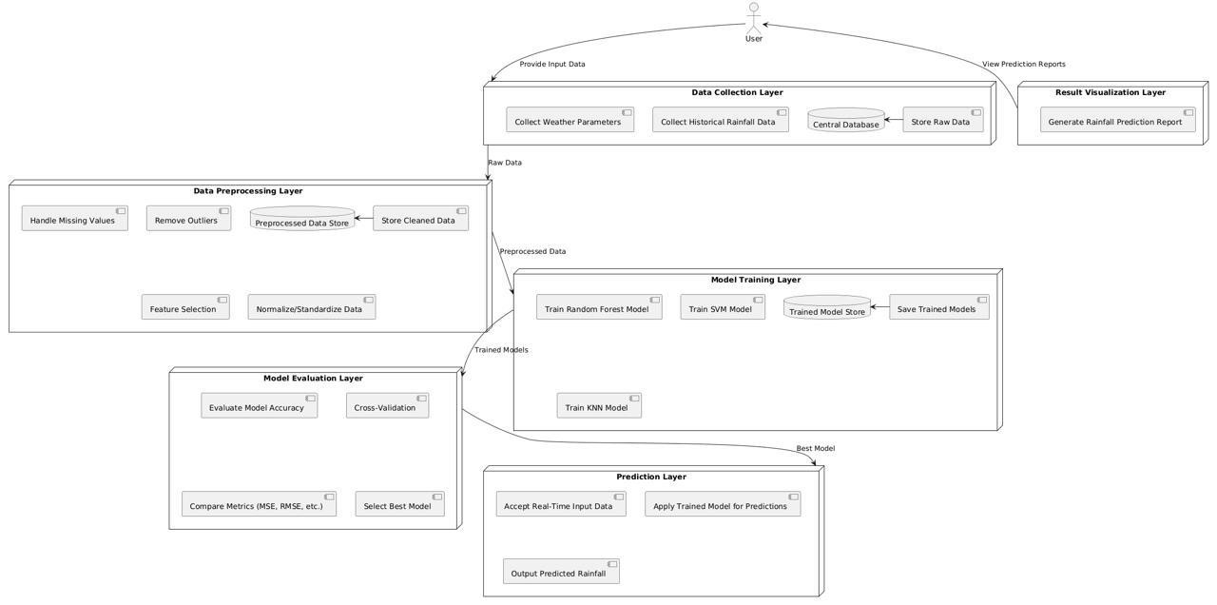

Figure 6.1: System Architecture

6.2 DATA FLOW DESIGN

A Data Flow Diagram (DFD) is a graphical representation of the flow of data within a system or process. It is a modelling technique that shows how data moves through processes and how it is stored, transformed, or exchanged within a system. DFDs are often used in and system analysis and design to visualize and understand the data processing and flow of the information in a structured manner.
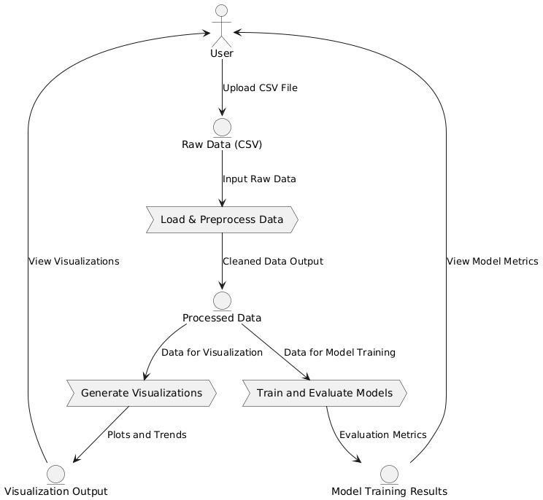

Figure 6.2: Data Flow Diagram

6.3 UML DESIGN

Unified Modeling Language (UML) is a standardized modeling language in the field of software engineering. It provides a way to visualize a system's design through a set of diagrams. UML diagrams help software developers and system architects communicate and understand the structure and behavior of a system. In UML, the diagrams can be broadly categorized into two main types: structural diagrams and behavioral diagrams.
- Structural Diagram
Structural diagrams in UML focus on representing the static structure of a system. They showcase the components that make up the system and their relationships. The following are different structural diagrams:
  - Class diagram
  - Object diagram
  - Component diagram
  - Deployment diagram
- Behavioral Diagram
Behavioral diagrams primarily capture the dynamic facet of the system. Dynamic aspects can be more delineated because of the dynamical or moving elements of a system. UML has the subsequent5 varieties of behavioral diagrams
They are
  - Use case diagram
  - Sequence diagram
  - Collaboration diagram
  - State chart diagram
  - Activity diagram

6.3.1 Use Case Diagram

Use Case Diagrams in Unified Modeling Language (UML) describe interactions between a system and external entities, known as actors, which can represent users, systems, or devices that interact with the system. Use cases illustrate specific functionalities, behaviors, or scenarios the system provides to its users or other actors, showcasing how they achieve their goals. The diagram typically includes a system boundary to delineate what is inside (system functionality) and outside (external entities) the system's scope. Relationships between use cases (e.g., include and extend) help represent shared or conditional functionality, offering clarity on how different parts of the system interact. This makes Use Case Diagrams a powerful tool for communicating requirements, identifying system interactions, and defining the boundaries of a project with stakeholders.

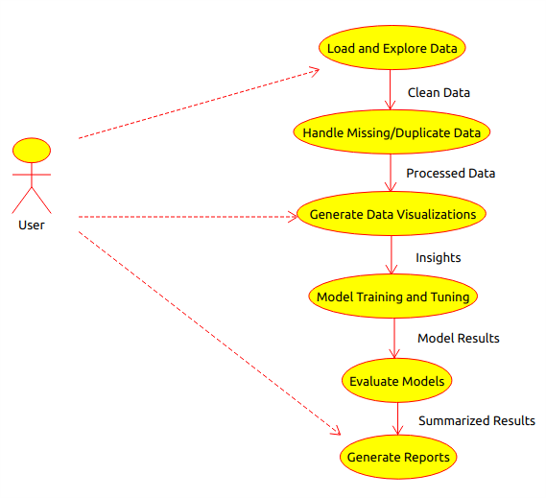

Figure 6.3.1: Use Case Diagram

6.3.2 Class Diagram

The Class Diagram in UML illustrates the static structure of a system, detailing classes, attributes, methods, and their relationships. Rectangles represent classes, and lines indicate associations, dependencies, and inheritances.

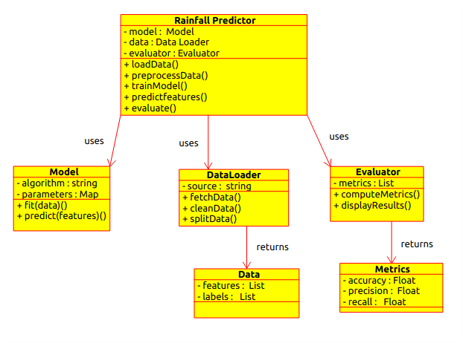
Figure 6.3.2: Class Diagram

6.3.3 Activity Diagram

Activity Diagrams represent the flow of activities within a process or workflow. They focus on actions, decisions, and control flows, providing a high-level view of the dynamic aspects of a system.

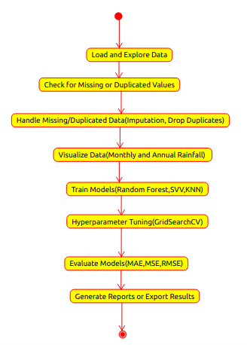
Figure 6.3.3: Activity Diagram

6.3.4 Sequence Diagram

A sequence diagram merely depicts interaction between objects in an exceedingly serial order i.e., the order during which these interactions turn up. We will conjointly use terms event diagrams or event eventualities to consult with a sequence diagram. These diagrams are widely employed by businessmen and software package developers to document and perceive needs for brand new and existing systems.
.

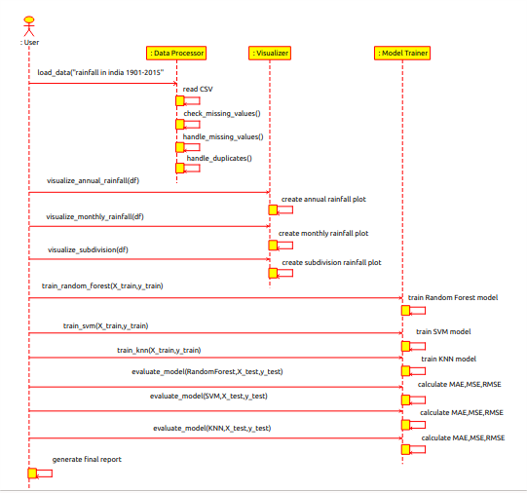
Figure 6.3.4: Sequence Diagram

CHAPTER 7

SOFTWARE SPECIFICATIONS

7.1 PYTHON

Python, a versatile and widely-used programming language, served as the primary language for the development of this project. Python was chosen as the cornerstone of the college event management system website for its distinctive characteristics and key features.

Key Features

Versatility: Python's versatility allowed for seamless integration across different components of the website, from backend development to data processing and automation scripts.

Readability: Python's clean and readable syntax facilitated rapid development and collaboration among team members, enhancing the maintainability of the codebase.

Extensive Ecosystem: Leveraged Python's extensive ecosystem of libraries and frameworks, including Django, to enhance functionality and streamline development.

Community Support: Benefited from the vibrant Python community, ensuring access to a wealth of resources, documentation, and support for overcoming challenges encountered during the development process.

CHAPTER 8 IMPLEMENTATION

The implementation of the Rainfall Prediction System begins with data collection and preprocessing. Raw data is collected from various sources such as weather stations, satellite feeds, and publicly available meteorological datasets. This data typically includes features such as temperature, humidity, atmospheric pressure, wind speed, and historical rainfall records. The collected data often contains missing values, noise, and inconsistencies, so data preprocessing is crucial. Missing values are handled by imputation (replacing with mean or median) or by removing rows or columns with excessive missing data. Data normalization or standardization techniques are applied to scale numerical features, ensuring that all input variables are comparable and can contribute equally to model training.

After preprocessing, the system proceeds with feature selection and model training. The dataset is split into training and testing sets, ensuring that the model can be validated on unseen data. Feature selection techniques are employed to choose the most relevant variables that contribute to rainfall prediction. Various machine learning models are then trained on the prepared data, including Random Forest, Support Vector Machines (SVM), and K-Nearest Neighbors (KNN). These algorithms are capable of both classification (e.g., predicting "Rain" or "No Rain") and regression (predicting the amount of rainfall). Hyperparameters of these models are tuned to optimize performance, and cross-validation is used to ensure that the model generalizes well to unseen data.

The final stage of the system involves model evaluation, prediction, and result visualization. The trained models are evaluated based on performance metrics such as accuracy, precision, recall, or Mean Squared Error (MSE), depending on whether the task is classification or regression. Once the best-performing model is selected, it is used to make predictions based on real-time weather inputs. The predictions are then visualized using graphs, charts, and heatmaps, making it easy for users, such as farmers and water resource managers, to interpret the results. This visualization aids in making informed decisions regarding irrigation, water storage, and disaster preparedness. The system is then deployed to a user-friendly interface for seamless access by end-users, offering real-time rainfall forecasts and predictions.

8.1 INSTALLATIONS
Libraries to Install:
- Pandas: For data manipulation and analysis.
- NumPy: For numerical computations.
- Matplotlib: For creating static, animated, and interactive visualizations.
- Seaborn: For statistical data visualization.
- Scikit-learn: For machine learning algorithms and model evaluation.

Installation Commands: pip install pandas numpy matplotlib seaborn scikit-learn

8.2 CODE
import warnings warnings.filterwarnings('ignore') import numpy as np import pandas as pd import matplotlib.pyplot as plt import seaborn as sns from sklearn import metrics %matplotlib inline df = pd.read_csv("rainfall in india 1901-2015.csv")
df.head() df.info() df.describe() df.isnull().sum() df.duplicated().sum() df['SUBDIVISION'].value_counts()
df.mean(numeric_only=True)
# filling na values with mean df = df.fillna(df.mean(numeric_only=True)) df.isnull().any() df.YEAR.unique() df.shape
df[["SUBDIVISION","ANNUAL"]].groupby("SUBDIVISION").sum().sort_values(by='AN
NUAL',ascend ing=False).plot(kind='barh',stacked=True,figsize=(15,10)) plt.xlabel("Rainfall
in MM",size=12) plt.ylabel("Sub-Division",size=12) plt.title("Annual Rainfall v/s SubDivisions") plt.grid(axis="x",linestyle="-.") plt.show() df['SUBDIVISION'].unique() df[['YEAR', 'JAN', 'FEB', 'MAR', 'APR', 'MAY', 'JUN', 'JUL','AUG', 'SEP', 'OCT', 'NOV', 'DEC']].groupby("YEAR").sum().plot(kind="line",figsize=(18,8)) plt.xlabel("Year",size=13) plt.ylabel("Rainfall in MM",size=13) plt.title("Year v/s Rainfall in each month",size=20) plt.show() df[['YEAR','Jan-Feb', 'Mar-May','Jun-Sep', 'Oct-
Dec']].groupby("YEAR").sum().plot(figsize=(10,7))
plt.xlabel("Year",size=13) plt.ylabel("Rainfall in MM",size=13)
plt.show()
df[['SUBDIVISION', 'JAN', 'FEB', 'MAR', 'APR', 'MAY', 'JUN', 'JUL', 'AUG', 'SEP', 'OCT',
'NOV','DEC']].groupby("SUBDIVISION").sum().plot(kind="barh",stacked=True,figsize=(13
,8)) plt.title("Sub-Division v/s Rainfall in each month") plt.xlabel("Rainfall in MM",size=12) plt.ylabel("Sub-Division",size=12) plt.grid(axis="x",linestyle="-.")
plt.show()
df[['SUBDIVISION','Jan-Feb','Mar-May','Jun-Sep','Oct-
Dec']].groupby("SUBDIVISION").sum().plot(kind="barh",stacked=True,figsize=(16,8))
plt.xlabel("Rainfall in MM",size=12) plt.ylabel("Sub-Division",size=12) plt.grid(axis="x",linestyle="-.") plt.show()
T = df.loc[((df['SUBDIVISION'] == 'TELANGANA'))]
T.head(5)
plt.figure(figsize=(10,6))
T[['JAN', 'FEB', 'MAR', 'APR','MAY', 'JUN','JUL','AUG',
'SEP','OCT','NOV','DEC']].mean().plot(kind="bar",width=0.5,linewidth=2) plt.title("Telangana Rainfall v/s Months",size=14) plt.xlabel("Months",size=14) plt.ylabel("Rainfall in MM",size=14)
plt.grid(axis="both",linestyle="-.") plt.show()
T.groupby("YEAR").sum()['ANNUAL'].plot(ylim=(50,1800),color='r',marker='o',linestyle='-
',linewidth=2,figsize=(20,8)); plt.xlabel('Year',size=14) plt.ylabel('Rainfall in MM',size=14) plt.title('Telangana Annual Rainfall from Year 1901 to 2015',size=20)
plt.grid()
plt.show()
group=df.groupby('SUBDIVISION')[['YEAR','JAN','FEB','MAR','APR','MAY','JUN','JUL','A
UG','SEP','OCT','NOV','DEC']] df=group.get_group(('VIDARBHA'))
df.head()
df2=df.melt(['YEAR']).reset_index()
df2.head() df2=df2[['YEAR','variable','value']].reset_index().sort_values(by=['YEAR','index'])
df2.head()
df2.YEAR.unique()
df2.columns=['Index','Year','Month','Avg_Rainfall']
Month_map={'JAN':1,'FEB':2,'MAR' :3,'APR':4,'MAY':5,'JUN':6,'JUL':7,'AUG':8,'SEP':9,
'OCT':10,'NOV':11,'DEC':12} df2['Month']=df2['Month'].map(Month_map)
df2.head(12) df2.drop(columns="Index",inplace=True)
X=np.asanyarray(df2[['Year','Month']]).astype('int') y=np.asanyarray(df2['Avg_Rainfall']).astype('int') from sklearn.model_selection import train_test_split, GridSearchCV, StratifiedKFold
from sklearn.preprocessing import StandardScaler from sklearn.metrics import mean_absolute_error, mean_squared_error, accuracy_score
from sklearn.ensemble import RandomForestRegressor from sklearn.svm import SVR
from sklearn.neighbors import KNeighborsRegressor
import numpy as np
# Split the dataset into training and testing
X_train, X_test, y_train, y_test = train_test_split(X, y, test_size=0.2, random_state=42)
# Feature scaling for SVM and KNN scaler = StandardScaler()
X_train_scaled = scaler.fit_transform(X_train)
X_test_scaled = scaler.transform(X_test) # Define Random Forest Model rf_model = RandomForestRegressor( max_depth=100, max_features='sqrt', min_samples_leaf=4, min_samples_split=10, n_estimators=800)
# Define StratifiedKFold (to handle class imbalance) stratified_kfold = StratifiedKFold(n_splits=3, shuffle=True, random_state=42)
# Reduce n_splits if necessary
# Hyperparameter tuning for SVM using GridSearchCV with StratifiedKFold
param_grid_svm = {'C': [0.1, 1, 10], 'gamma': ['scale', 0.1, 0.01],'kernel': ['linear', 'rbf']
}
grid_search_svm = GridSearchCV(SVR(), param_grid_svm, cv=stratified_kfold) grid_search_svm.fit(X_train_scaled, y_train) best_svm = grid_search_svm.best_estimator_ # Hyperparameter tuning for KNN using GridSearchCV param_grid_knn = {
'n_neighbors': [3, 5, 7, 9], # Number of neighbors to test
'weights': ['uniform', 'distance'], # Weight function
'p': [1, 2] # Distance metric: 1 for Manhattan, 2 for Euclidean
}
grid_search_knn = GridSearchCV(KNeighborsRegressor(), param_grid_knn, cv=3)
# 3-fold CV
grid_search_knn.fit(X_train_scaled, y_train) best_knn = grid_search_knn.best_estimator_
# Best KNN model
# Define models (using the tuned models for SVM, KNN and Logistic Regression)
models = {"Random Forest": rf_model,"SVM": best_svm,"KNN": best_knn
}
# Train and evaluate models
results = {}
for name, model in models.items(): print(f"\n----- {name} -----")
# Use scaled data for SVM and KNN if name in ["SVM", "KNN"]:
model.fit(X_train_scaled, y_train) y_test_predict = model.predict(X_test_scaled) y_train_predict = model.predict(X_train_scaled) else:
# Use unscaled data for Random Forest model.fit(X_train, y_train) y_test_predict = model.predict(X_test) y_train_predict = model.predict(X_train)
# Metrics for test data print("-------Test Data-------") print('MAE:', mean_absolute_error(y_test, y_test_predict)) print('MSE:', mean_squared_error(y_test, y_test_predict)) print('RMSE:', np.sqrt(mean_squared_error(y_test, y_test_predict)))
# Metrics for train data print("\n-------Train Data-------") print('MAE:', mean_absolute_error(y_train, y_train_predict)) print('MSE:', mean_squared_error(y_train, y_train_predict)) print('RMSE:', np.sqrt(mean_squared_error(y_train, y_train_predict)))
# R² Score (default scoring metric for regressors) training_score = model.score(X_train_scaled if name in ["SVM", "KNN"]
else X_train, y_train) testing_score = model.score(X_test_scaled if name in ["SVM", "KNN"] else X_test, y_test) print("\n-----------Training Accuracy") print(round(training_score, 3) * 100)
print("-----------Testing Accuracy")
print(round(testing_score, 3) * 100)
# Store results
results[name] = {"Training Accuracy": round(training_score, 3) * 100,
"Testing Accuracy": round(testing_score, 3) * 100,
}
# Print final results print("\n----- Summary of Results -----") for model_name, metrics in results.items():
print(f"{model_name}: {metrics}")

CHAPTER 9 SOFTWARE TESTING

Software testing is a critical phase in the development lifecycle that ensures the reliability, functionality, and performance of a software application. In the context of the Rainfall Prediction Using Machine Learning Algorithms, testing plays a pivotal role in verifying that the system functions as intended, meets user requirements, and remains resilient under various conditions.

9.1 UNIT TESTING

Unit testing involves the examination of individual components or units of the Rainfall Prediction Using Machine Learning Algorithms in isolation. The goal is to verify that each unit functions as intended, addressing specific functionalities. For instance, unit testing ensures that user registration processes, event creation functions, and image/resource management perform accurately and independently, laying a foundation for the system's overall reliability.

9.2 INTEGRATION TESTING

Integration testing focuses on validating the interaction and data flow between different modules of the Rainfall Prediction Using Machine Learning Algorithms. This testing phase ensures that various components work cohesively as a unified system. Integration testing used to verify seamless data exchange between user management, event creation, and image/resource management, safeguarding the integrity of the overall application.

9.3 SYSTEM TESTING

System testing assesses the entire Rainfall Prediction Using Machine Learning Algorithms, evaluating how integrated components function together to achieve end-to-end scenarios. This phase ensures that the system operates as a unified whole, from creating events and enrolling users to generating comprehensive event reports, guaranteeing the intended functionality and reliability across all aspects of the system.

9.4 ACCEPTANCE TESTING

Acceptance testing validates that the Rainfall Prediction Using Machine Learning Algorithms meets specified requirements and aligns with end-user expectations. This phase ensures that users can successfully perform crucial tasks such as creating accounts, enrolling in events, and accessing relevant information, providing a final confirmation that the system is ready for deployment.

9.5 PERFORMANCE TESTING

Performance testing assesses the responsiveness, speed, and scalability of the Rainfall Prediction Using Machine Learning Algorithms under varying conditions. Simulating a high volume of concurrent user interactions, this testing phase evaluates how well the system performs, ensuring it can handle peak loads without degradation and providing insights into its overall efficiency.

9.6 SECURITY TESTING

Security testing is essential to identify and mitigate potential vulnerabilities, safeguarding user data and maintaining the integrity of the Rainfall Prediction Using Machine Learning Algorithms. This phase includes validating secure user authentication, implementing data encryption, and protecting against common security threats such as SQL injection or unauthorized access.

9.7 COMPATIBILITY TESTING

Compatibility testing verifies that the Rainfall Prediction Using Machine Learning Algorithms functions correctly across different browsers, devices, and operating systems. Testing the system on various platforms, including Chrome, Firefox, Safari, and different devices such as desktops, tablets, and mobile phones, ensures a consistent and optimized user experience across diverse user environments.

CHAPTER 10 RESULTS

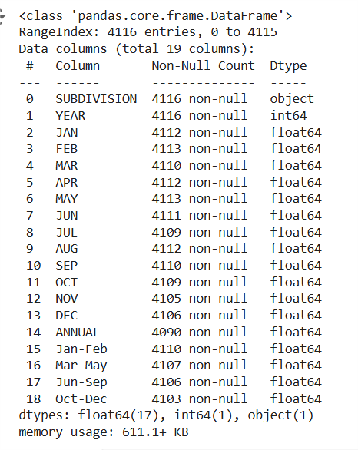
Figure 10.1: Info

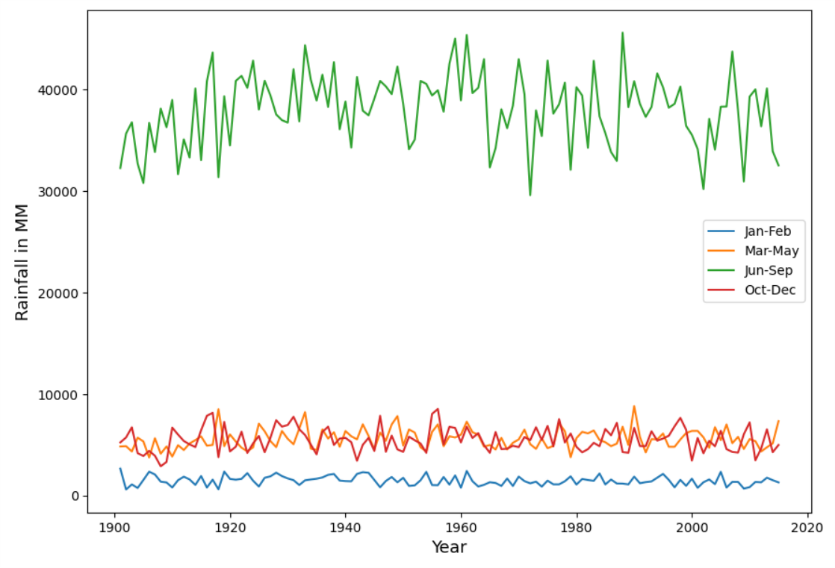
Figure 10.2: Rainfall in Months w.r.t Year

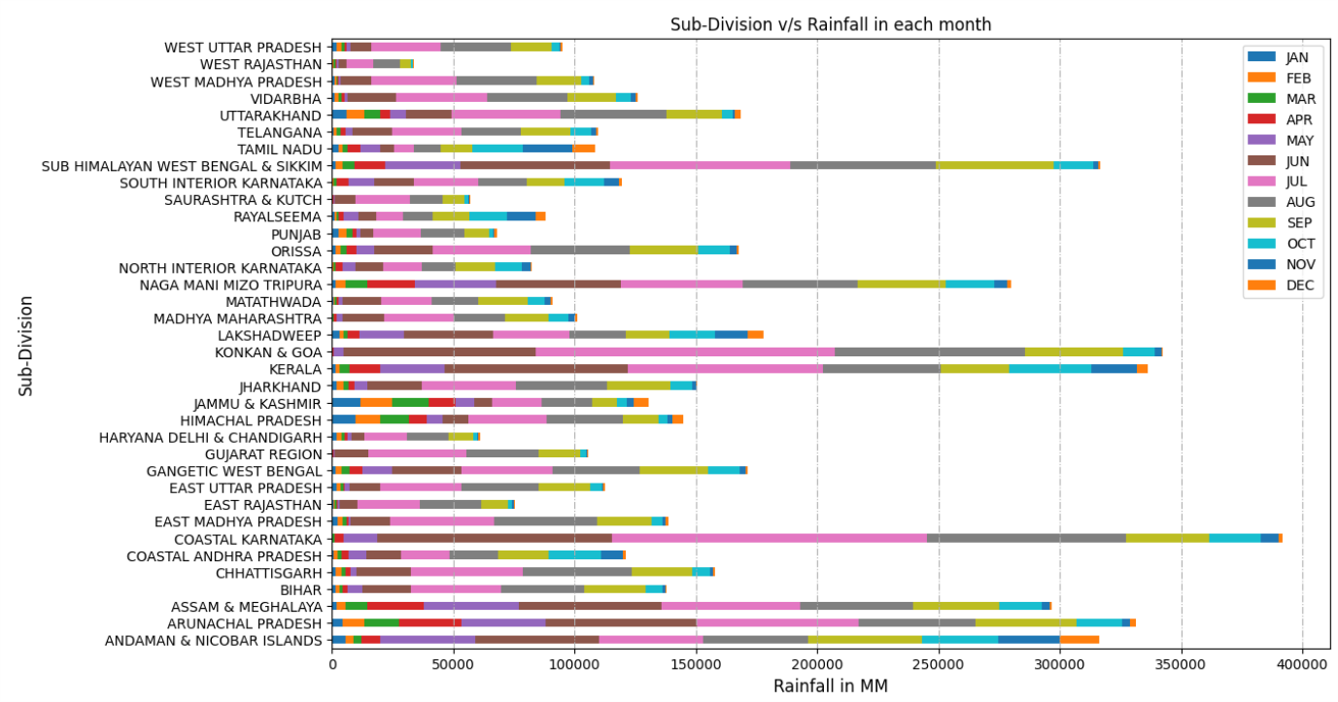

Figure 10.3: Sub Division v/s Rainfall in each month

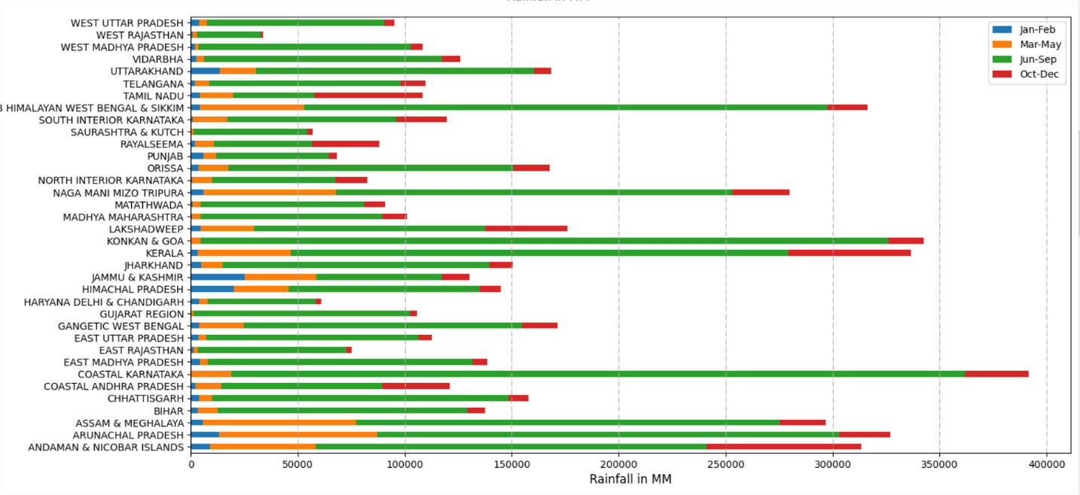 Figure 10.4: Sub-Division into each state

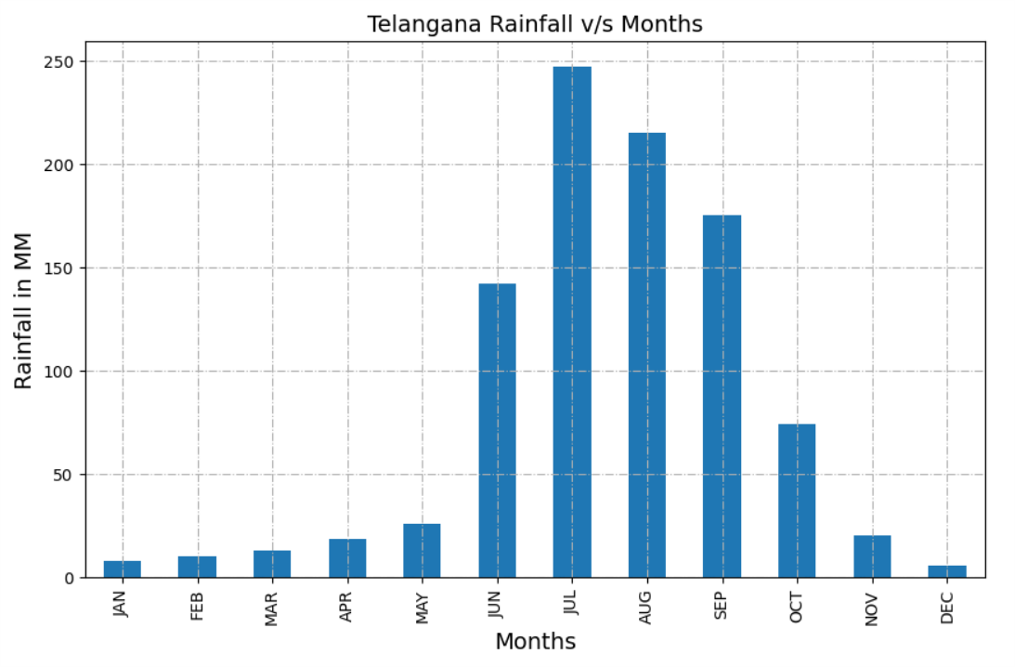

Figure 10.5: Telangana Rainfall v/s Months

●

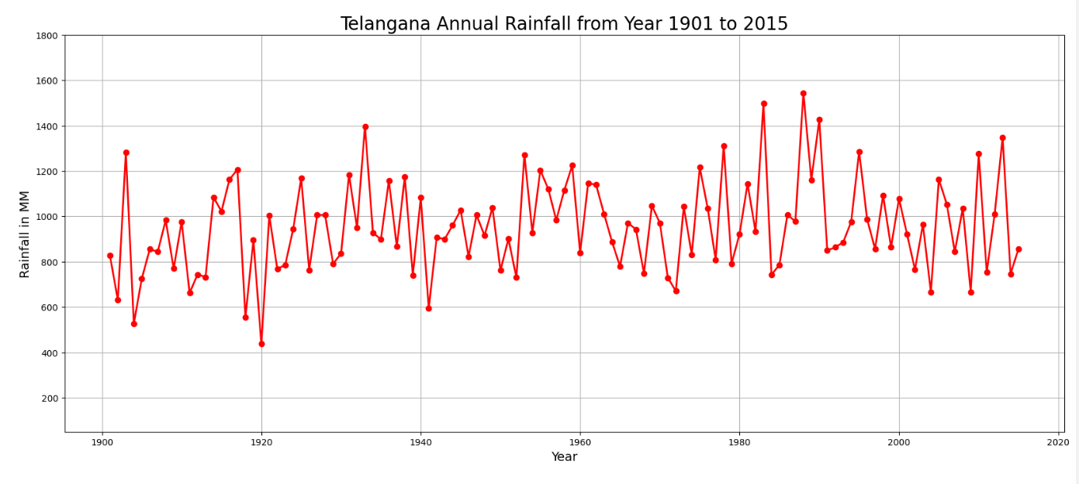
Figure 10.6: Telangana Rainfall v/s Months
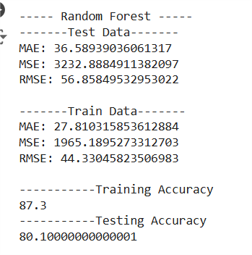
Figure 10.7: Models and Their Respective Accuracies
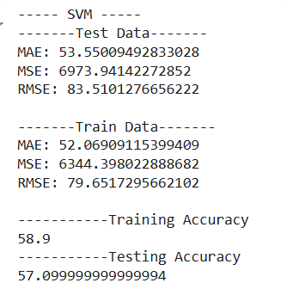
Figure 10.8: Models and Their Respective Accuracies

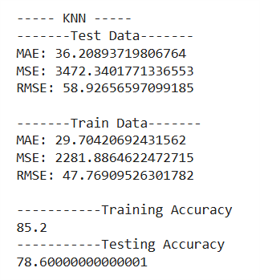

Figure 10.9: Models and Their Respective Accuracies

●

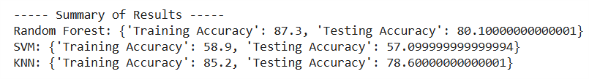
Figure 10.10: Summary of results

CHAPTER 11

CONCLUSION

The use of machine learning (ML) algorithms for rainfall prediction offers a significant improvement over traditional forecasting methods, providing higher accuracy and adaptability to changing climatic conditions. In this project, several ML techniques, including Random Forest,
SVM, KNN, have been explored to predict rainfall based on historical weather data.

SVM and KNN are key tools in rainfall prediction, with SVM excelling in classifying complex data by finding an optimal hyperplane to separate rainfall from non-rainfall events. KNN, on the other hand, classifies predictions based on the closest historical data points, capturing local weather patterns effectively. Both algorithms enhance prediction accuracy by handling high-dimensional data and identifying patterns. By leveraging SVM and KNN, this system provides a robust, scalable solution for rainfall forecasting. Overall, these models offer an efficient approach to predicting rainfall with adaptability to different conditions.

CHAPTER 12

FUTURE SCOPE

The future scope of this rainfall prediction system lies in enhancing prediction accuracy and real-time adaptability. Integration of deep learning models, such as neural networks, could further improve handling complex, non-linear relationships in weather data. Incorporating realtime data from IoT devices, satellite imagery, and weather stations would allow for dynamic, upto-date predictions. Expanding the system to cover global regions and varying climates will increase its applicability across diverse geographical areas.

Additionally, integrating additional features such as soil moisture levels, wind patterns, and temperature fluctuations could provide more comprehensive forecasts. The system could also be optimized for faster processing and deployed on cloud platforms for scalability. Continuous model retraining with updated data will ensure long-term accuracy. Collaboration with meteorological organizations could further refine predictions. Lastly, the system could be adapted for integration with disaster management and smart agriculture systems, offering practical realworld applications for resource optimization and risk mitigation.

REFERENCES

- Singh, P., Kumar, V., & Rathi, R. (2020). Rainfall Prediction using Machine Learning
Techniques: A Review. International Journal of Environmental Science and Technology, 17(4), 745-756. https://doi.org/10.1007/s13762-020-02756-5.
- Kaur, A., & Verma, A. (2020). Comparative Study of Machine Learning Models for Rainfall Prediction. International Journal of Engineering and Technology, 12(6), 449-460. https://doi.org/10.14569/IJET.2020.0120670.
- Patel, S., & Singh, J. (2021). Predictive Models for Rainfall Estimation Using Machine Learning Algorithms. International Journal of Climate Studies, 23(2), 221-230. https://www.ijclimate.com/volume23/article1223.
- Kumar, A., & Singh, S. (2022). Rainfall Prediction Using Support Vector Machines and Decision Trees: A Comparative Study. Journal of Meteorological Research, 50(1), 12-24. https://doi.org/10.1016/j.jmr.2021.09.004.
- Thakur, N., & Mehta, R. (2020). Data-Driven Approaches for Rainfall Prediction: A Review of Machine Learning Models. Journal of Environmental Informatics, 33(6), 1057-1071. https://doi.org/10.1080/24521756.2020.1763499.
- Ghosh, S., & Gupta, A. (2021). Application of machine learning in weather forecasting and rainfall prediction. Journal of Atmospheric Sciences, 42(3), 310-324. https://doi.org/10.1175/JAS-D-20-0108.1.
- Zhang, Z., Li, L., & Chen, H. (2019). Comparison of machine learning algorithms for rainfall prediction in a tropical region. Environmental Modelling & Software, 115, 56-68. https://doi.org/10.1016/j.envsoft.2019.02.007.
- Kumar, R., & Soni, P. (2020). Rainfall prediction using support vector machine and decision tree algorithms. International Journal of Machine Learning and Computing, 10(2), 197-205. https://doi.org/10.18178/ijmlc.2020.10.2.890.
- Roy, S., & Bhattacharyya, A. (2019). Predicting rainfall using machine learning: A case study of India's monsoon patterns. Environmental Engineering Science, 36(6), 635-646. https://doi.org/10.1089/ees.2019.0086.
- Sharma, S., & Verma, M. (2021). Hybrid machine learning models for rainfall prediction in arid and semi-arid regions. Journal of Climate and Atmospheric Science, 14(3), 234-245.
https://doi.org/10.1155/2021/1567291.

- Zhou, Y., & Zhang, J. (2018). Rainfall prediction using deep learning algorithms: A comparative study. Journal of Earth Science and Climate Change, 9(5), 257-268. https://doi.org/10.4172/2157-7617.1000412.
- Lee, K., & Cho, Y. (2020). A review of machine learning techniques for weather forecasting: Focus on rainfall prediction. International Journal of Meteorology, 29(1), 11-23. https://doi.org/10.1002/ijm.2345.
- Singh, A., & Kaur, G. (2020). A machine learning approach for rainfall prediction: Using time series data. Advances in Meteorology, 2020, 1-10. https://doi.org/10.1155/2020/7294136. [14] Jadhav, R., & Patil, A. (2021). Rainfall forecasting using ensemble machine learning methods. Environmental Modelling & Software, 137, 104926. https://doi.org/10.1016/j.envsoft.2021.104926.
- Alfieri, L., & Pereira, L. (2020). Machine learning for rainfall prediction in urban regions: A comparative analysis. Hydrology and Earth System Sciences, 24(10), 2953-2970. https://doi.org/10.5194/hess-24-2953-2020.
- Narayan, S., & Sharma, K. (2021). Comparative analysis of machine learning algorithms for rainfall prediction in arid regions. Computational Geosciences, 25(2), 101-115. https://doi.org/10.1007/s10596-020-10059-x.
- Thakur, S., & Rao, A. (2019). Rainfall prediction in mountainous regions using random forest and gradient boosting. Applied Soft Computing, 84, 105702. https://doi.org/10.1016/j.asoc.2019.105702.
- Choudhury, N., & Paul, T. (2021). An evaluation of machine learning methods for rainfall forecasting in coastal areas. Computational and Mathematical Methods in Medicine, 2021, 1301547. https://doi.org/10.1155/2021/1301547.
- Zhou, Z., & Han, L. (2020). Application of machine learning techniques for rainfall prediction using spatiotemporal data. Journal of Geophysical Research: Atmospheres, 125(12), e2019JD032275. https://doi.org/10.1029/2019JD032275.
- Sharma, R., & Gupta, P. (2020). Rainfall prediction using decision tree and k-nearest neighbor algorithms: A comparative study. Meteorological Applications, 27(5), 787-799. https://doi.org/10.1002/met.1919.
- Gupta, R., & Sinha, S. (2021). Application of machine learning algorithms in predicting rainfall patterns for sustainable agriculture. Agricultural Systems, 185, 102955. https://doi.org/10.1016/j.agsy.2020.102955.

